INFANT JESUS PARISH

Finance Committee and
Ministry Coordinators Reports
For the Annual Community Meeting

MONDAY, 24 NOVEMBER 2025, 7.00PM
INFANT JESUS PARISH CENTRE, MORLEY

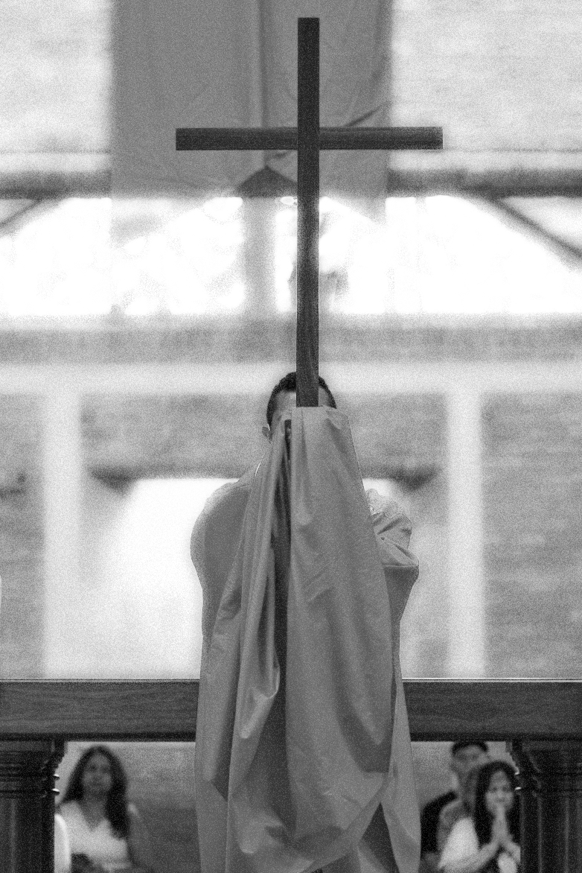

“In a divided and troubled world,
the Holy Spirit teaches us to walk together in unity”
- Pope Leo XIV

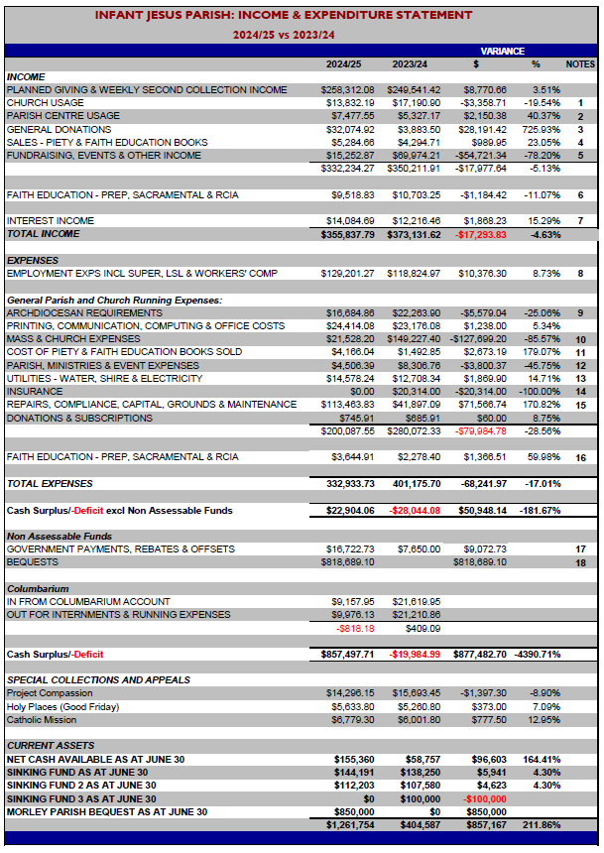

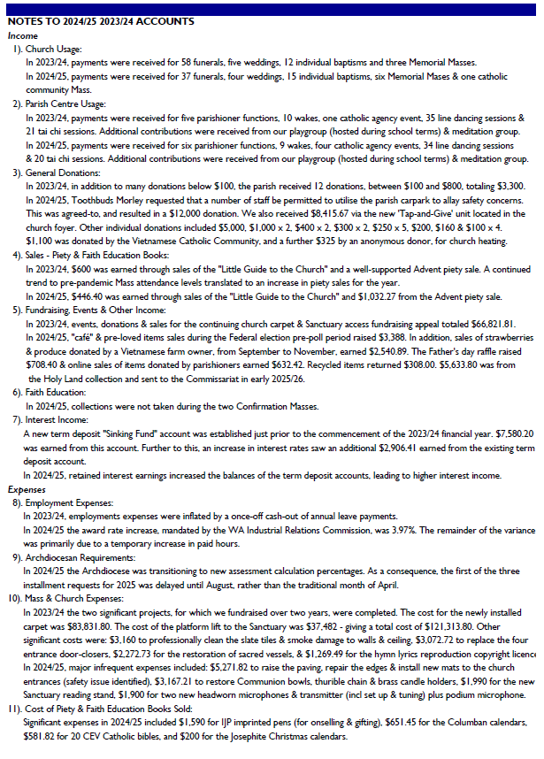
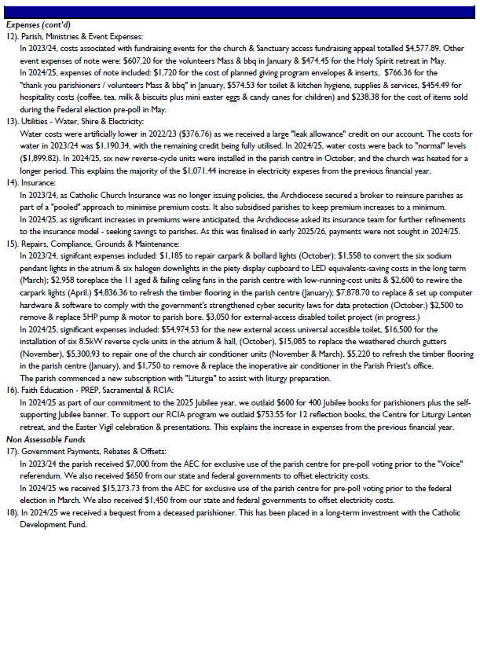

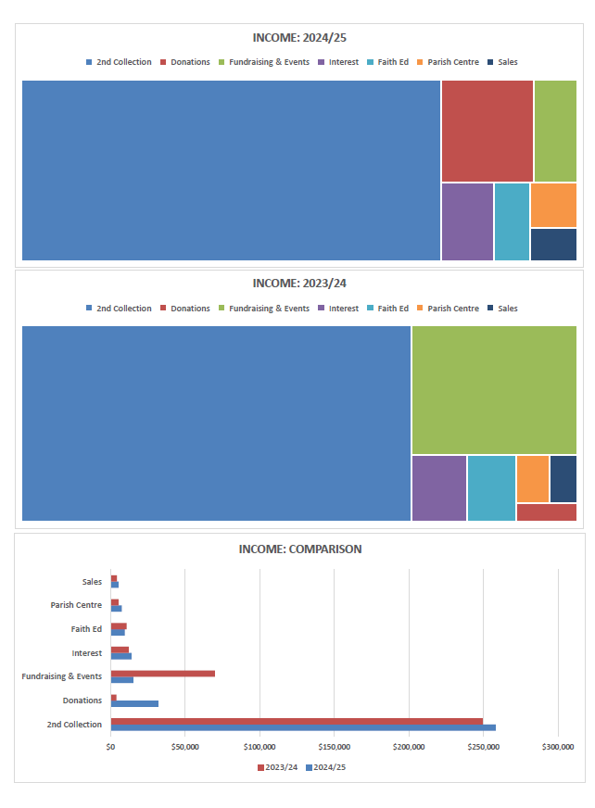
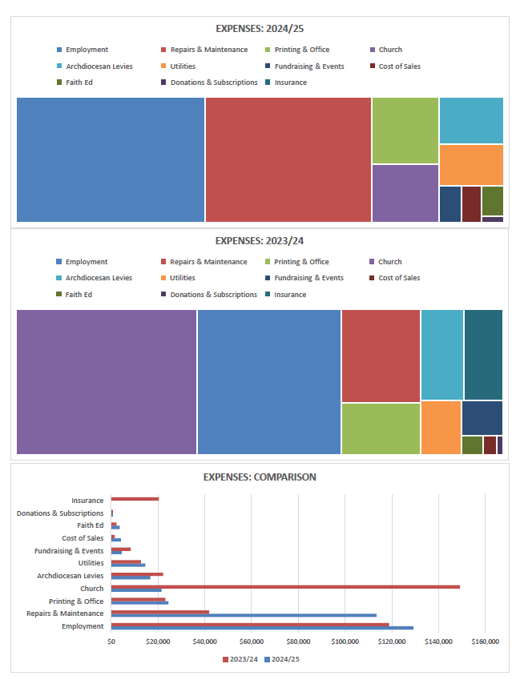
FINANCE REPORT
The responsibility for the finances of the Parish rests with the Parish Priest, currently Fr Greg.
However, to assist him in making financial decisions, a Parish Finance Council is in place.
The day-to-day financial operations are managed by the Parish Finance staff.

Thanks to the continued generosity and support of our parishioners, the Parish’s financial position remains strong, allowing us to meet our ongoing commitments. In particular, due to a bequest from a past parishioner, as part of his estate, the Parish has been able to bring forward several maintenance projects and capital works over the past 12 to 16 months, as listed:

Significant Expenses 2024/25

Raise paving, repair edges and install mats to church entrances (safety issue) | $5,271.82
Sacred vessels restoration - Communion bowls, thurible chain, brass candle holders | $3,167.21
Install six 8.5kW Hisense reverse cycle units to parish centre atrium & hall areas | $16,500.00
Construction of new universal accessible toilet with external access | $54,974.53
Replace church gutters | $15,085.00
Remove and replace inoperative air conditioner in Parish Priest's office | $1,750.00
Repairs to church evaporative air conditioner unit | $5,300.93
Clean, refresh and coat parish centre timber floors (preventative maintenance) | $5,220.00
TOTAL | $107,269.49

Significant Expenses 2025/26
(As at 30 October 2025)

Install eight 19kW Hisense reverse cycle units to church (incl central control unit) | $66,949.98
Replace church lighting control unit | $4,367.61
Sacred vessels restoration - Chalice, pattens | $3,280.18
Remove and replace inoperative air conditioner in reception office | $1,800.00
Remove & replace worn carpet in reception, PP office & library with carpet tiles | $2,977.31
Remove & replace weathered parish centre lattice & paint external southern walls | $17,861.82
Replace & set up reception PC | $2,203.00
TOTAL | $99,439.90

A copy of the Parish Income and Expenditure Statement for the year ending 30 June 2025 is attached for your information.

Ivor Byrde, Parish Finance Council Chairman
COLUMBARIUM COMMITTEE REPORT

At the end of another year, the committee would like to thank, once again, the volunteers who assist in keeping the columbarium gardens healthy and looking beautiful. We welcome Marilyn Summerset onto the team and thank her for the regular work she has been performing recently. We also sincerely thank David and Lila Vaughan
for their sustained efforts in trying to save the roses in the garden from chilli thrip. Unfortunately, it was recently decided that the battle has been lost and consequently all the roses in the columbarium have been removed. The garden will remain empty for a period to ensure the thrip have dispersed before replanting with alternative plants.

Reservations, applications and internments

The changes made to the columbarium General Conditions towards the end of 2024 have had the desired effect of slowing the number of applications for niches quite significantly. In the past year we have received only 13 new applications. This will allow us more time to reflect on and plan for future development of the columbarium.

We had only 8 interments over the year, a significant drop from 2024.

We encourage people who are interested in reserving a niche or making enquiries to make an appointment with the columbarium team by contacting the Parish office.

The committee continue to receive enquiries from other parishes requesting information and assistance in planning their own columbarium and we are always happy to share our parish’s experience.

Please consider volunteering

The Columbarium is regularly attended by parishioners and their families. They very much appreciate the quiet beauty of the area and the significance of what it represents. A place to feel safe and privately commune with their family and friends. The committee would like to encourage parishioners to volunteer to become a part of the team.
There are many ways to assist, whether you can do occasional gardening, cleaning or maintenance, some filing and paperwork, meet with prospective or already booked family members (or their loved ones), attend internment services, or small acts of kindness...it would all be most welcome.

Andrew Davini and Angela Youens

PARISH RELIGIOUS EDUCATION PROGRAM (PREP) REPORT

The Parish Religious Education Program (PREP) is mandated by the Archdiocese of Perth and overseen by Catechist Services under the Catholic Education Western Australia. Any family whose child/ren, attend non-Catholic schools, and wish them to receive religious education and/or to be prepared for the Sacraments of Baptism, Reconciliation (Penance), First Communion (Eucharist) and Confirmation should apply for PREP.

It is open to school aged children from Prep-primary/Year 1 and upwards and requires preparation to extend over a two year period for Reconciliation and First Communion and over a further two year period for Confirmation. Classes are held in the parish centre each week on Wednesdays from 4.15 - 5.20pm during the school terms. The children generally seem very happy to come along and catch up with their PREP friends and learn their prayers and about the love of God. This spiritual journey of our children is progressing well considering the limited time we have with them each week.

Our parish catechists are a generous group of parishioners who volunteer to teach the children their faith and love of God. As a parish we are very blessed with their dedication and care of our parish children. Some of our catechists have taught for many years but each one is a very valuable member of our catechist team. I thank Sylvia Brough, Morag McPherson, Linda Doyle, Sandra Jones, Eric Dias, David Ward, Beverly Ferriera and Rebecca Magalad and Julien Athave who have taught or been an assistant over this year. I would like to thank all these wonderful people who give so generously of their love of our God and their time.

Catechist Services have written a wonderful catechism resource program for the catechists to use in teaching the children. The program is very organized with scripture quotes and reflections plus all the wording, questions and answers for catechists to say and activities for the children to complete during class time. It is a very easy program to follow. If anyone feels a calling to be a catechist please contact Sue at prep@infantjesusparish.org.au or call in on a Tuesday or Wednesday morning to talk with Sue.

We also have a Rite of Christian Initiation of (older) Children (RCIC) program for anyone over 10 years old (Year 4) whose parents want them to learn their Catholic faith and be prepared for the Sacraments. Our catechist, Linda Doyle, works with this small group of children on a Tuesday afternoon, after school. The children and parents are all very happy with this program.

This year we have had 59 children enrolled for PREP (52) and RCIC (7) of which the following have received their Sacraments –

Confirmation – 12 children in June
First Communion – 8 children in September
Reconciliation – 12 children in November.
RCIC (7) = 5 @ Reconciliation, First Communion & Confirmation; 2 @ Confirmation only.

On the last week of Term 2 and 4 we organised a family Mass for the all the classes, their families and friends together in the church which is then followed by a little afternoon tea party under the patio of the parish centre. At the end of Term 3 we all watched a video of the story of our new Saint Carlo Acutis and had a little party after. Any parishioner is very welcome to join us for Mass as well.

Thank you also to our parish priests Fr Greg, Fr John and Fr Adalbert for their support during the year and with our Masses. Also, to our parish office staff, thank you for your much valued friendship and support throughout the year.

This is my 12th year as PREP coordinator which has been a pleasure to work with everyone involved.

Sue Goodwin, PREP Co-ordinator

SACRAMENTAL PROGRAM REPORT
It has been a wonderful year of celebration for our PREP children and Infant Jesus children with them receiving the Sacraments in their primary years.

Enrolment is implemented online via the Microsoft form link sent out to parents and booking of the masses/family retreats & reconciliation is via Eventbrite. Feedback has been very positive and we will continue with this system down the road. There is no more filling of physical forms thereby reducing cost, time and storage space.

The table below shows the number of children who received the sacraments this year:-

 | Infant Jesus School children | PREP children | Total
Sacrament of Reconciliation  (November) | 54 | 12 | 66
Sacrament of First Eucharist  (September) | 50 | 8 | 58
Sacrament of Confirmation  (June) | 45 | 11 | 56

The Sacramental Masses for First Communion and Confirmation this year were held separately from the weekend masses to reduce overcrowding. The families involved have responded well to the situation. Overall, the celebrations are felt to be more intimate and involved. We had 2 masses each for Confirmation and First Communion on a Saturday. The masses were at full capacity as families and friends came together to celebrate the children’s special day.

Collections from the Sacramental Masses amounted to $1184.

The sacramental fee has stayed the same at $35 but families are absorbing the ticketing fee of $3.37 charged by the online booking system (Eventbrite) this year. We used to absorb the fee. With the latest practice, we are getting the full fee of $35 for each child enrolled for the sacramental program. There has not been any negative feedback so that’s good news. Please bear in mind the $35 fee only covers a small portion of the cost in running the programs.

The 24.7 Youth Ministry has been running the Sacramental Retreats for the children for some years now and have been doing a wonderful job at it. Infant Jesus Primary School has generously absorbed the cost of the retreats for each of the Sacraments (Reconciliation, First Eucharist and Confirmation) for 2025 amounting to around $3000. The parish is very grateful for their support.

Acknowledgements are forthcoming for the following ministries without which the sacramental program cannot be implemented: Acolyte & Altar Servers Ministry, Hospitality Ministry, Music Ministry (special thanks to Lenny Ong and Belinda Chia and their choir), Flower Ministry, Environment Ministry and the Proclaimers Ministry.

The parish staff (Lucy, Andrew, Darren, Carol, Sue & Marisol) has been invaluable and such a great help in making the programs a success for all the children and their families. Volunteers in the office; Lyn and Josie are godsend. Special mention to Angela Youens and Sue Goodwin for their advice. The facilitators who stepped up for the workshops (some for all three sacramental workshops!); Sr Chau, Sr Chitra, Linda Doyle, Jenni Jobe, Tung, Judy David, Darren Parnell, Tanya Davis, Sandra Jones, Travis Leggett, Nevellene Lindquist, David Ward, Angela Younes and Andrew Panizza. This is truly a communal Sacramental Team!

The Infant Jesus School staff and teachers especially Ms Mel Allen, Mr Frank Colangelo and Ms Sandra Mullen have been very helpful and supportive throughout. Last but not least, my special thanks to our priests Fr Greg, Fr John and Fr Adalbert for their guidance and advice.

Theresa Choo, Sacramental Coordinator

BAPTISM PREPARATION FOR PARENTS REPORT

Baptisms are held every 1st and 3rd Sundays of the month in our parish. To date, we celebrated 43 baptisms for children below 7 years of age.

From December this year, baptisms will be celebrated every 1st and 3rd Saturdays of the month.

This year, we had Sue Baile, Cheryl Davini, Sally Palmer and Chris Andrews facilitating the meetings for the parents which are held once a month. The parish extends a big thank you for their time, commitment and faith sharing!

Theresa Choo, parish office

CLEANING MINISTRY REPORT

There are 4 teams cleaning our church on a weekly basis and the parish wishes to express our gratitude to the dedicated teams in keeping the house of God spick and span. A big shout-out to Nancy Bagnato who has stepped down from her many years of volunteering in cleaning the church. We welcome Jane Hille, Fely Palermo, Shirley De Mello, Joanne Mennell, Sylvie Thornton and Lynda Pjevac to the ministry. Many of our kind volunteers have been committed to this for years and we hope for younger and committed ones to step up to this very important ministry especially with our spanking new carpet in place.

Theresa Choo, parish office

EXTRAORDINARY MINISTERS OF HOLY COMMUNION MINISTRY REPORT

Presently we have 48 people involved in the Ministry and despite a recently held recruitment drive, this is the same number that I reported on twelve months ago. Besides these people involved in our Sunday Masses, there are also other Extraordinary Ministers who participate in the Italian Mass and the weekday masses.
I would like to thank all Members of our Ministry on behalf of the Parish for their dedication to this important work in our Parish.
We also have another team of people under the leadership of Sabina Wright who regularly take Holy Communion to the sick in our Parish and to those in hospitals.
We need new people to join our Ministry to assist in this important work in our Parish.
Michael Foley, Coordinator

LITURGY COMMITTEE REPORT

With the new liturgical year fast approaching, the committee has already met and prepared the need of the liturgies for Advent and the Christmas Season.
There were a few changes of ministry leadership in the group at this meeting.
We welcomed Suchita to the group as she is taking over from Sue Baile in the coordination of the writing of the Prayer of the Faithful.
I would like to thank Sue for her work and contribution to the parish liturgy over the last few years. Thank you, Sue.
Dawn was welcomed into the group and she will be representing Children’s Liturgy of the Word. Dawn will be one of the connections for the children and their parents’ inclusion in the seasonal liturgies of the church as well as coordinating the regular Mass time for ‘breaking open the Word’ for young children.
Alisha joined us and she will be ensuring the proclaimers’ ministry and its needs is represented at the meetings as the ministry’s leadership is in transition. Thank you Marina for your contribution to the liturgy and the proclaimers’ ministry in our parish.
Thank you to all who support the work of the people – the liturgy- in our parish. This includes all, those who sing, stand, kneel and participate together. Thank you
“Mother Church earnestly desires that all the faithful should be led to that fully conscious, and active participation in liturgical celebrations which is demanded by the very nature of the liturgy” (14). Constitution on the Sacred Liturgy
“The Church, therefore, earnestly desires that Christ’s faithful when present at this mystery of faith, should not be there as strangers or silent spectators; on the contrary, through a good understanding of the rites and prayers they should take part in the sacred action conscious of what they are doing. Active participation—while it includes such things as vocalising the responses—is primarily about the intellectual contemplation and heartfelt intentionality of the faithful during the liturgy. It is about actively thinking of what is being said, what it means, and consenting with one’s will to the sacred mysteries taking place.”
Jocelyn Versace, Coordinator

MAINTENANCE REPORT

2025 has been another typical year for a 60-year-old Parish Centre and 30-year-old Church, with general repairs and replacements.

Major items that were completed include:
Completion of the new Accessible Toilet,
Reverse Cycle Air Conditioning in the Church,
New electronic control Centre for the Church Lighting,
New air conditioner in the Main Office,
Installation of an all-weather awning outside the toilet doors,
New carpet in the Main Office, Parish Priest’s Office, and Library,
Cleaning up and re-painting of the Atrium’s ground floor
Completed the painting of the outside of the Parish Centre
Cleaning and resurfacing of the wooden floor in the Parish Hall and Atrium.

The day-to-day maintenance of a large Parish like Infant Jesus would not be possible without the constant assistance of a large team of volunteers. To the wonderful men and women that have helped this year, from the annual rose pruning, setting up and clearing away for each event, moving furniture from offices and library for the carpet laying, to the daily repairs to sprinklers, weeding and rubbish pick up, thank you so much.
Grateful thanks also to our Parish Priest Fr. Greg and Fr John and Fr Adalbert for their support in progressing the work that has been done.

Our 2025 team includes:
John Cogdon
David and Lilia Vaughn
Peter Bevilacqua
John Strijk
Ivor Byrde
Mike Foley
Eric Mok
Jenny Thomas
Leon Dique
John Boog
Guy Gaudet
Carmel Cotter and
John Tomczak

If you would like to join this dynamic, active and friendly team, please contact the office.

Andrew Davini, Maintenance Manager

PARISH INCLUSION REPORT

The role of Parish Inclusion Coordinator began several years ago when the Archdiocesan agency, Personal Advocacy Service, requested parishes nominate one person to become the liaison between PAS and local parishes. Personal Advocacy was formed to support people with intellectual disability to become more included in their own local parish and local community.
Every third Sunday of the month, at our 9.30am Mass, we incorporate a number of unique features that allow our friends with disabilities to better understand the liturgy. At these Masses, together with their volunteer Advocates, our Friends with Intellectual Disability:
- join with other Hospitality Ministers to welcome parishioners
- participate in the Entrance procession
- ceremonially lay the cloth on the Altar
- participate in the Offertory procession
- lead us in the Responsorial Psalm
- participate in a physical enactment of the Readings on the Sanctuary which allows everyone to see, as well as hear the Word of God
It is clear that our Friends feel very comfortable whenever they join us at these Masses. For these adapted liturgies, our priests are encouraged to reduce their Homily to one line – which they repeat three times. Many of our parishioners tell us that these homilies are the most memorable and that our Adapted Liturgies have a significant effect on them and their families.
After every monthly adapted liturgy, Friends, Advocates and parishioners are invited to join us for Morning Tea in the parish centre. This social interaction is also very important for everyone involved, including the small group of volunteers who set-up; serve; and clean-up after this social gathering.
Sue Baile, Coordinator

BEREAVEMENT SUPPORT GROUP REPORT

As a result of the Volunteering weekend, we have welcomed a number of new people to this group. Our group now has 15 members who come together once a month to share a special Mass and Morning Tea with those who have recently lost a loved one.

On the first Tuesday of every month, we invite bereaved family members to bring along a photo of their deceased loved ones which is then placed on the Sanctuary before the Mass begins. These photos not only comfort the bereaved, they also allow other regular weekday Mass attendees to recognize the people for whom the Mass is being celebrated. Our special Mass is followed by a Morning Tea which is prepared by the members of our Support Group. It’s hard to resist ‘Jam and Cream Scones’ and other snacks prepared by our generous volunteers.

Each year, on 2nd November we also prepare the Church for our All Souls Day Mass. We organize banners showing the names of those who have passed away in the past 12 months and whose Funerals were held in our parish. We also hang a special Banner to recognize deceased Carmelite Friars who faithfully served in our parish.

Each family that attends this special celebration is invited to place a candle on the Sanctuary in memory of their deceased loved ones. This special Mass is then followed by the Blessing of the Columbarium and a simple Morning Tea or Supper.

Sue Baile, Coordinator

PRAYERS OF THE FAITHFUL REPORT

‘Pray without ceasing….’ (1 Thessalonians 5:17)

St Paul encouraged the Thessalonians to be constant and open in their communication with God – to rejoice with God in their good times and to bring their concerns to Him during difficult times. Jesus often encouraged us to boldly ask for all our needs. With this in mind, each weekend, through the Prayers of the Faithful, we pray for our own needs and the needs of our world.

A small group of our parishioners, encouraged and overseen by Fr Greg, prepare the Prayers of the Faithful for all Sunday liturgies and special Feast Days. Using recommended resources such as ‘Liturgy Help’ and ‘Pastoral Liturgy’, as well as personal reflection on the Readings for the upcoming Sunday Masses, we focus on the changing themes of each theological season.

Together with Catholics around the world, each week we specifically pray for the leaders of our Church; our secular leaders; the local community; the sick and the deceased and ask for God’s loving intervention in our daily lives.

Sue Baile, Coordinator

MUSIC MINISTRY REPORT

Our Music Ministry plays a vital role in enriching our worship and supporting our spiritual growth through the beauty and power of music.

We are truly grateful for our dedicated musicians, singers, and computer operators, who generously share their time and God-given talents with our parish. Their commitment helps lift our hearts in prayer and draws us closer to God.

Updates from the Year
- We warmly welcome Bel back to the Music Ministry. She has generously offered to lead the music at the Sunday 6.00pm Mass on the 5th Sunday of each Month, together with filling in any vacant slots.
- We thank Linda for delaying her annual break so that music can be provided for the Feasts of the Holy Family, the Epiphany and Baptism of Our Lord.
- When the Sunday 9.30am Choir took a break earlier this year, several music groups stepped in to ensure music continued at that Mass.

Enhancing Our Liturgies
- To further enrich our liturgies, we are planning to introduce the singing of the Psalm at selected weekend Masses. Currently, six parishioners are undertaking a four-week Psalmist course to be trained in singing the Psalms. We look forward to incorporating this beautiful expression of Scripture into our worship.
- The Environment Team, together with Father Greg, has prepared a new PowerPoint template to better reflect the tone and reverence of the liturgy. All choir leaders are now in the process of adopting this template. We thank the Environment Team for their work, and we thank the choir leaders for their cooperation and effort.

Weekend Music Ministry Roster
We have a musician rostered for every weekend Mass except the 7.30am, which normally does not have music. If a musician is unable to fulfil their rostered date, every effort is made to find a replacement.

Saturday 6.00pm
- Tracey and Aini – 1st Sunday of the month
- John – 2nd Sunday of the month
- Bernie – 3rd, 4th and 5th Sunday of the month

Sunday 7.30am
No regular music, except on special Feasts or parish celebrations

Sunday 9.30am
- Linda – 1st, 2nd, 4th, and 5th Sunday of the month
- Priscilia and Roma – 3rd Sunday (Personal Advocacy Mass)

Sunday 6.00pm
- Lenny – 1st Sunday of the month
- John – 2nd Sunday of the month
- Bernie – 3rd Sunday of the month
- Tessie and Orlando – 4th Sunday of the month
- Bel – 5th Sunday of the month

Music Ministry Drive
Following our recent Ministry Drive, several people expressed interest in joining as singers. They have been invited to attend the usual pre-Mass choir practice and introduce themselves to the choir leader.

Looking Ahead
We will continue welcoming new members and strengthening our Music Ministry so that our worship remains prayerful, uplifting, and rooted in our love for God.

Computer Operators
Our computer operators are an important part of the Music Ministry roster. Each operator is assigned to a regular Sunday each month, which helps ensure consistency and supports the musicians by allowing them to focus fully on leading the music.

Appreciation and Gratitude
I thank Fr Greg, Fr John Fr Adalbert and all parishioners for your ongoing encouragement and support. A special thanks to Fr Adalbert for his leadership, guidance and commitment of the Music Ministry.

My gratitude also extends to the volunteers who manage our computer systems, and to our talented musicians and singers for their dedicated service.

In closing, the Music Ministry remains committed to serving our parish community through the gift of music, inspiring us to worship with one heart and to grow together in faith. We look forward to another year of unity, prayer, and spiritual renewal.

Thank you for your continued trust and support in our Ministry.

Yours sincerely in Christ,

Judy David, Coordinator

PROCLAIMERS of the WORD MINISTRY REPORT

The proclaimer is not just reading from a book but is the instrument through which God’s voice is heard.

Our Team
I am pleased to share that we have a team of 43 weekend proclaimers and teams who proclaim at the weekday Masses (7:00am, 9:00am) and the Sunday Italian Mass at 11:00am.

We warmly welcomed Lia DeMello (Sun 9:30am) and Georgia Mammone (Sun 6pm) to our weekend team and thank them for committing to this ministry! We welcome back Gerri Nayar (Sun 7:00am) to the team.

I wish to thank our weekday roster coordinators; John Orzanski (7:00am Mass) and Sylvia Brough (9:00am/8:30am Mass) for their contribution in facilitating proclaimers at the weekday Masses. Also, I wish to thank Vienna Pizzino for coordinating the Italian Mass team of proclaimers.
Introduction of the New Revised Standard Version (NRSV) Readings
At Infant Jesus Church we commenced the use of the NRSV readings for weekend Masses at commencement of Year C, the first Sunday of Adent 2024.

Coordinator Role in 2025/6
It has been my pleasure to work alongside the very dedicated and committed proclaimers at Infant Jesus Church over the last 7 years. I have now retired as coordinator, and the ministry is looking for someone to fill this position. There will be plenty of support available and I will assist in the transition. Anyone interested and considering this position should contact the parish office for more details.

In the interim Alishia Sequeira has generously offered to fill the gap. I sincerely thank Alishia for her assistance.

My thanks …
On a personal note, I wish to thank the proclaimers for their support of me. Working with them has been a pleasure and a highlight in my faith journey. They have adopted the changes asked of them, attended practice sessions in preparation for our major celebrations and their teamwork and commitment to the roster has made my role easy and rewarding.
I thank them for making the Word of God come alive in a personal and powerful way.
Thank you.
Marina MacLean, Coordinator

PARISH OFFICE REPORT

It has been a privilege stepping into the role of Parish Secretary this year. As a newcomer to the parish office, I have been greatly inspired by the warmth, generosity, and dedication of our community.
We began the year with our annual Thanksgiving Mass and BBQ for volunteers, open to the whole parish, providing a wonderful opportunity to acknowledge everyone who gives their time and talents.
In January, we also launched our new parish website, which has greatly improved communication, promoted events, made the bulletin accessible, and provided resources for parishioners and new members.
In June, our Ministry Drive brought in new volunteers despite the poor weather, and our online volunteer registration continues to make joining ministries easier. A special thanks to the coordinators of each ministry who joined in the drive with vigour and enthusiasm.
In August, we celebrated the 32nd Anniversary of the Dedication of the Church, a joyful multicultural event where parishioners shared dishes from their cultures.
September brought occasion for parishioners to deepen their faith through a pilgrimage to the Jubilee Door at St Mary’s Cathedral, receiving plenary indulgences, and some travelled further afield to Europe, visiting the Carmelites in Spain, Lisieux in France, and Lourdes, amongst other sites enriching their spiritual experience and sharing it with the parish through regular updates.
Another highlight was the Spring Sale in November, a successful event welcoming the wider public community into the Parish Centre, fostering connection, and raising funds to support the parish and local social welfare groups.
The parish centre remains a lively hub, hosting study groups, meditation, retreats, Taichi, playgroup, Vinnies, and social activities. Daily parish office duties include managing bookings, sacramental enquiries, bulletins, records, and supporting priests, volunteers, parishioners, and the Archdiocese.
This year we also celebrated Fr Greg’s 75th birthday, Fr Adalbert’s 40th, and are preparing for Fr Greg’s Golden Jubilee to be celebrated with the Archbishop.
We also welcomed new coordinators for Proclaimers, Prayers of the Faithful, and Children’s Liturgy.
I sincerely thank Fathers Greg, John, and Adalbert, our staff, and volunteers for their support, guidance, patience, and generosity. Finally, I thank the parish community for your encouragement and look forward to continuing to serve together in the year ahead.

Lucy Christides, Parish Secretary

CHURCH’S PIETY STALL REPORT
Our Piety Stall is regularly open at Sunday 7:30am and 9:30am Masses, offering Bibles, cards, rosaries, gifts, reflection and children’s books, prayer cards, and statues, with special stalls for Lent and Advent. This year, we also held a clearance sale at the Spring Sale, making stock more accessible to the wider community.
We thank our dedicated team for their ongoing support. This year we welcomed Cheryl Blake and Ya Tan to the 9:30am team and Sr Maddy who opens the piety stall at 7:30am on Sunday mornings. Special thanks to Roma Bamford, Anne Bowley, Andrew Davini and Peter Sigle for their invaluable contributions and dedication to keeping the piety stall open and well stocked.
Volunteers are always welcome, particularly for Saturday 6pm and Sunday 6pm Masses where there is currently no piety stall open. No experience needed—just a willing heart. Please contact the parish office if you can help.

Lucy Christides, Parish Secretary

ALTAR MINISTRIES REPORT

As we come towards the end of the Jubilee Year, we find our ministries that assist at the altar going from strength to strength. I would like to extend my gratitude to all the Acolytes, Senior Altar Ministers, Altar Servers and their families for their participation and support throughout 2025 to our ministries and parish.

We currently have active in our parish 7 Acolytes, 7 Senior Altar Ministers and approximately 36 Altar Servers. We are fortunate to have another Acolyte who has recently joined the ministry and I will be training 3 new Senior Altar Ministers later this month. The Senior Altar Minister are from our Altar Servers who are now old enough to become Senior Altar Ministers and wish to progress to this new role as adult members of our ministry.

We have also reached out to our community here in the school and the parish to invite other children who have recently made their First Holy Communion, to come and join our Altar Server Minister and we will be having training for new members later this month.

At this point I would also like to acknowledge Fr Greg and his strong and patient leadership for the members of our altar ministries. His knowledge of liturgy and his guidance has been invaluable to our members and to myself personally and we wish him well in this next chapter of his life.

I would also like to remember Bob Collopy who passed away recently. He was member of the first team of acolytes in our parish. We thank God for his service to our ministry and community and pray for comfort for his family.

We look now towards Advent and then the coming of Christmas and the New Year and the changes of what 2026 will bring to our parish with joy and excitement for another great year.

Chris Lambert Altar Ministries Coordinator

SAFEGUARDING OFFICERS REPORT

I would like to thank Fr Greg for his unwavering support of the SGO to assist us in laying the foundation of what we can do to make our parish a safe place for our children and vulnerable adults.
We have attended two Roundtable forums with another one next week which brings us together with SGO from other parishes for open discussions. We have highlighted the importance of open conversations and child safety at all masses on Safeguarding Sunday in September. We attended the morning tea at the Cathedral in August and supported the Volunteer Thanksgiving Mass in May. We have now completed this year’s SAAT.
This is the tenth anniversary of the Safeguarding program and we have seen that safeguarding is not just a policy, it is a culture that integrates behaviours and communication into our daily practices at Infant Jesus parish, ensuring the safety of both children and adults.

Julie Lambert, Co-ordinator for SGOs

CHILDREN’S LITURGY REPORT
This year has gone by very quickly and many leaders have joined us though a few had to leave due to various personal commitments. We currently have 12 leaders and have finally found a coordinator, Dawn Smith, who have just taken on the task of leading team. Over the last few years, the team had literally run on their own, with the photocopied resources.

This is a very satisfying ministry, seeing young children eager to learn about God, and join in the activities. The children’s liturgy takes place during the 9.30 mass, after the initial blessing and before the consecration of the body and blood of Christ. These sessions happen during the school term except on the third Sunday of the month when we have our Personal Advocacy mass.

As the calendar year comes to a close, here’s wishing the parish families a safe and blessed holiday. God bless.

Linda Yapp, 2025 Coordinator

HOSPITALITY MINISTRY REPORT

At the outset, may I express my heartfelt appreciation to every Hospitality Minister for your faithful service throughout the year. Your commitment has been the quiet strength behind the warm, welcoming spirit of our parish.
As 1 Peter 4:9 reminds us: “Offer hospitality to one another without grumbling.”
This verse beautifully reflects the joy, generosity, and grace with which you serve. Thank you for ensuring that all who enter our church feel seen, valued, and embraced.

Key Events and Services
This year, the Hospitality Ministry continued to play a vital role in many of our major celebrations, including Christmas, Easter, First Communion, and Confirmation.
The team’s dedication—whether through preparing the space, greeting parishioners, or offering quiet support behind the scenes—helped enrich these important moments and strengthened our sense of unity as a parish family.

Name Tag Sunday
Name Tag Sunday remains one of the most successful and heart-warming initiatives. By encouraging everyone to wear their name tags, we make our community more approachable and personal. This simple act continues to build connection, deepen friendships, and ensure every person feels at home. It has truly become a cherished part of strengthening belonging within our parish. I often smile to myself when the Proclaimers find it hard to stop the Parishioners from their “get to know your neighbour” conversations 😊.

Volunteer Recognition, Recruitment & Growth
New Volunteers Welcomed This Year
- Christina Buan (6:00pm Saturday)
- Rebecca Nguyen (6:00pm Saturday)
- Eliana Castillo (6:00pm Saturday)
- Phung Anh Tran (7:30am Sunday)
- Shirley D’Mello (7:30am Sunday)
- Lia deMello (9:30am Sunday)
- Cynthia Bustan (9:30am Sunday)
- Lai Riko (9:30am Sunday)
- Victoria Mok (9:30am Sunday)
- Caroline Dias (9:30am Sunday)
- Karina Kho (6:00pm Sunday)
- Molly Saji (6:00pm Sunday)
- Vinola Dsouza (6:00pm Sunday)
- Steve Shehan (6:00pm Sunday)

With Gratitude, We Farewell:
- Manisha Mascarenhas
We honour and thank all who have retired or moved to other ministries or parishes. Their contributions have helped shape our community and their service is deeply appreciated.

June Recruitment Drive
A major highlight for our ministry this year was the Recruitment Drive held on 21st and 22nd June, which was an overwhelming success.

Through this initiative, 14 new volunteers joyfully stepped forward to join the Hospitality Ministry. These new members have been actively serving and fully integrated into the roster since July this year, contributing fresh energy, dedication, and enthusiasm to our team.

We are incredibly grateful for their willingness to serve and for the vibrancy they bring to our ministry.

As we look to the year ahead, I feel hopeful and inspired. The Hospitality Ministry is more than a roster of duties—it is a living expression of love, welcome, and community. The Minister’s willingness to serve is essential to our parish mission of being a place where all feel safe, supported, and spiritually nourished.

Together, we will continue building a church environment that truly feels like home.

With gratitude and prayer,
Josephine McManus, Coordinator

